Computer Language Coding Concepts

Active Clause in a Diagram
The principle of active clauses is explained in the article Active Clause. The current article demonstrates its expression in a diagram.

A clause is a command defined within a command.

An active clause is shown in a diagram as a diamond placed inside a command symbol:



A clause can just as well be placed inside another diamond, instead of a square:



A clause will never redirect its definition or object to another command.

Active clauses can freely be used to put a frame around a piece of code inside a command. In that case the whole command will still do exactly the same thing:

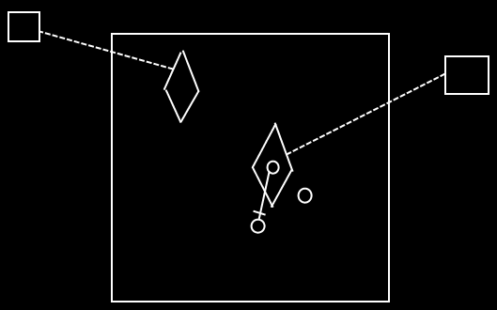

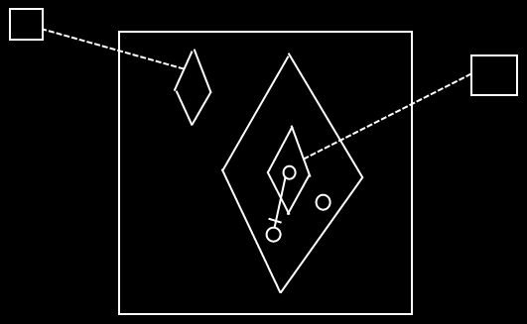

See also: Active Clause, Commands

Author & Copyright: Jan-Joost van Zon Date: May 25, 2008 – August 12, 2008 Location: Oosterhout, The Netherlands Status: Finished

